Project Design Phase-II
Technology Stack (Architecture & Stack)

Date | 11 february 2026
Team ID | LTVIP2026TMIDS41011
Project Name | Visualization Tool for Electric Vehicle Charge and Range Analysis
Maximum Marks | 4 Marks

Technical Architecture:
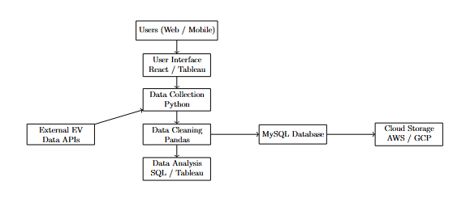
Table-1 : Components & Technologies:
S.No | Component | Description | Technology
1 | User Interface | Interface through which users view dashboards and interact with system | HTML, CSS, JavaScript, React JS, Tableau Dashboard
2 | Application Logic-1 | Data collection from multiple EV datasets | Python, MySQL Connectors
3 | Application Logic-2 | Data cleaning and preprocessing | NumPy, Pandas, Python Scripts
4 | Application Logic-3 | Data visualization and analytics logic | Tableau, SQL Queries
5 | Database | Stores EV datasets, processed data and metadata | MySQL Database
6 | Cloud Database | Cloud storage for large datasets and backups | AWS RDS / Google Cloud SQL
7 | File Storage | Stores raw dataset files (CSV, Excel, JSON) | Local File System / Cloud Storage
8 | External API-1 | EV charging station data source API | Open EV Data APIs
9 | External API-2 | Global EV statistics and vehicle information API | Government EV Open Data APIs
10 | Machine Learning Model | Predict EV range and usage patterns (future enhancement) | Python ML Models (Scikit-learn)
11 | Infrastructure | Application deployment environment | Local Server / Cloud Hosting (AWS)

Table-2: Application Characteristics:
S.No | Characteristics | Description | Technology
1 | Open-Source Frameworks | Frameworks used for data processing and visualization | Python, Pandas, NumPy, Tableau Public
2 | Security Implementations | User authentication, data protection, database security | SSL Encryption, Role-Based Access Control
3 | Scalable Architecture | System supports increasing data size and users | 3-Tier Architecture, Cloud Storage
4 | Availability | System accessible anytime with minimal downtime | Cloud Hosting, Backup Systems
5 | Performance | Optimized queries, fast dashboard loading, efficient data processing | SQL Optimization, Tableau Extracts, Indexing

